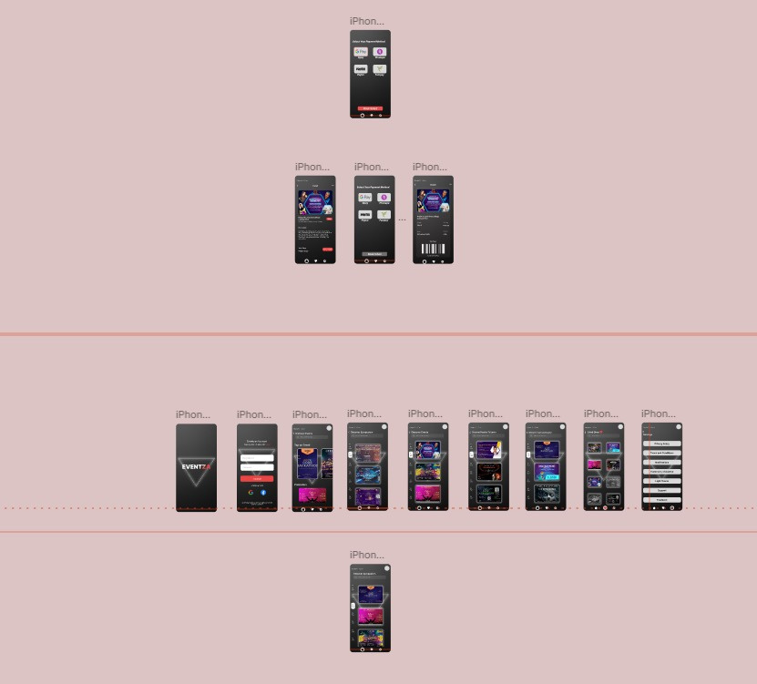

**Eventza**

**Analysis**

* **Goal**: Create an app for discovering, organizing, and attending events (concerts, conferences, parties, etc.).
* **Users**:
  + Event organizers (create and manage events).
  + Attendees (find and join events).
* **Needs**: Easy event discovery, seamless ticket purchasing, event details, and personalized recommendations.
* **Features**: Event search, ticket purchase, event details, notifications, user profiles, and event creation.

2. **Ideation**

* **Home Screen**: Display featured events, categories (music, sports, conferences), and a search bar.
* **Navigation**: Simple menu (Home, My Events, Profile, Notifications).
* **Search**: Filters for date, location, type of event, and price.
* **User Flow**: Sign up → Browse events → View event details → Purchase tickets → Attend event.
* **Wireframes**: Sketch layout for home page, event details, and ticket purchase flow.

3. **Modeling**

* **Prototype**: Design interactive mockups using tools like Figma or Adobe XD.
* **Test**: Run usability tests with potential users to improve the flow and design.

Result

* **Final Design**: A user-friendly app with a clean interface for browsing events, easy ticket purchasing, and personalized recommendations.